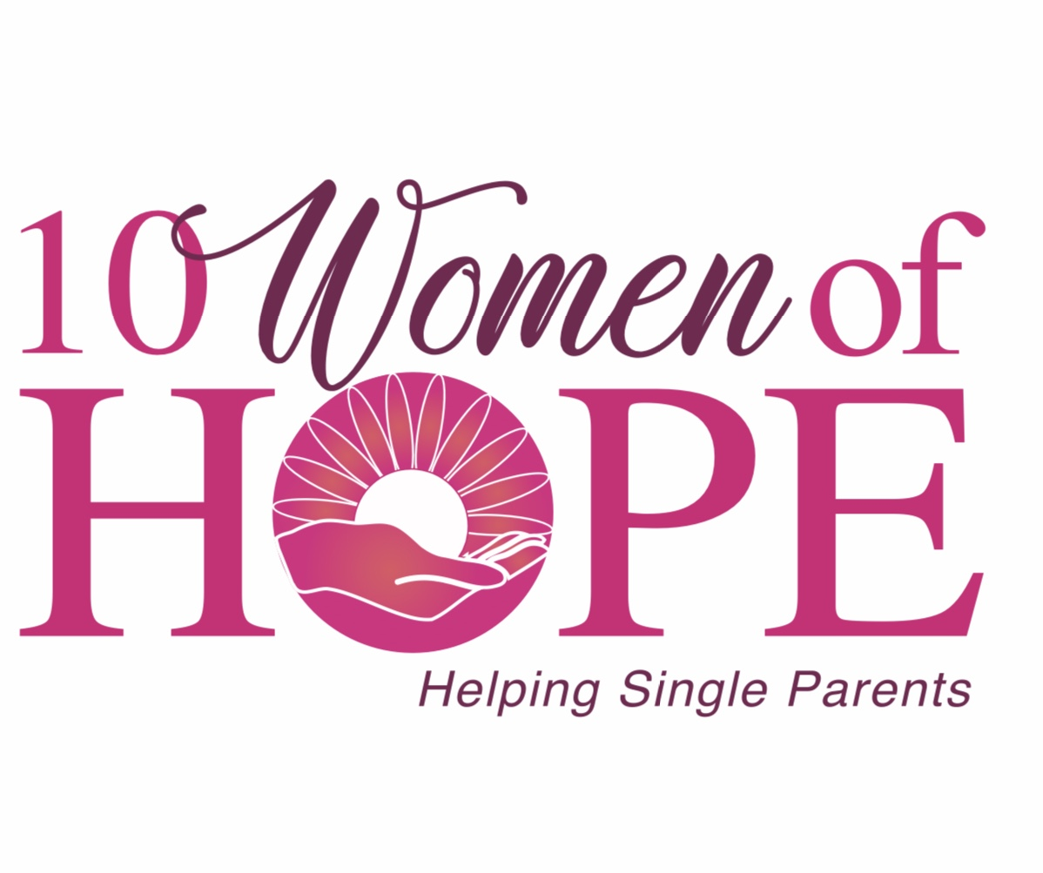

SAVE THE DATE!

Girls Night Out
Thursday, October 24, 2019
5PM until 8PM
The Brickyard at Marietta Station~129 Church Street, Marietta
$25 Minimum Donation

Plan to join us for this FUN, traditional event!
Shopping with new and favorite-returning vendors, great music,
hors d"oeuvres and drinks
&
celebrate the gift of “girlfriends “
All in the spirit of raising funds to support single parent families!

For more information or ticket sales visit us at www.10womenofhope.org
or contact any of the 10 Women of Hope:
Lamuriel Adams, Patsy Bryan, Wanda Callahan, Angie Davis, Laurel Kovach, Linda Palmer, Jacki Payne, Michelle Sams, Fran Sutton and Penny Warren

